Billy is a city dwelling, culturally disconnected indigenous man who is being terrorized by a Wendigo spirit. His family means everything to him, so when the Wendigo begins to also terrorize his son, Billy realizes he has to do the one thing he has avoided, return back to his home reservation where it all began.
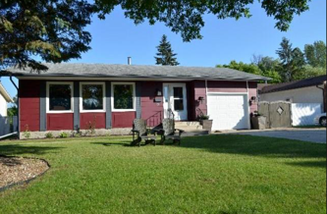  Billy’s house – warm and welcoming. Billy left the rez to start a new life and is eagerly working to pay off his new humble abode. | 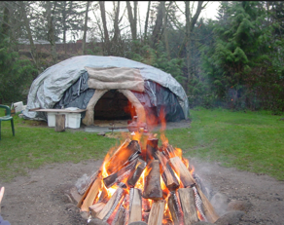  Sweat lodge (On Reserve) – This represents the culture and the spiritual balance that Billy missed when he fled for the city. Upon Billy’s return he is connected with his past. | 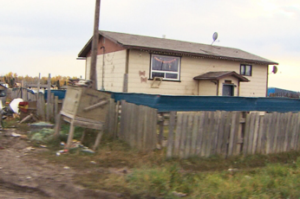  The rez – dry, morbid, tenacious, isolated. This is the house where Billy was raised and where he experienced all the emotional and physical trauma.
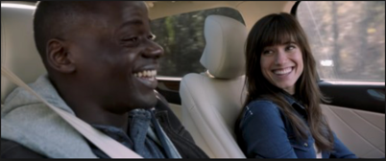  The car is where Billy and Linda escape the day to day nomenclature. | 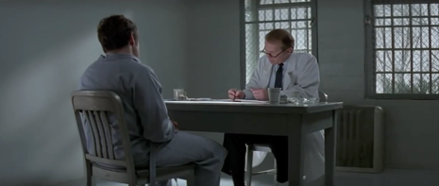  Therapy session with Dr. Miles. Billy had a great rapport with his psychiatrist since he was a boy. | 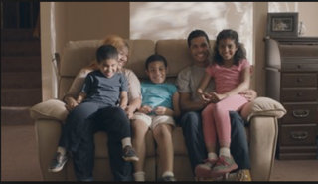  Billy values his family over everything and has worked his whole life to give his family the warm and welcoming home they deserve.
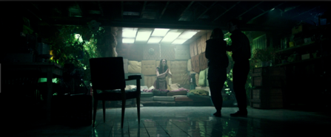  Damp basement where it all went wrong. It represents the dark secret Billy has been hiding and his entire life. | 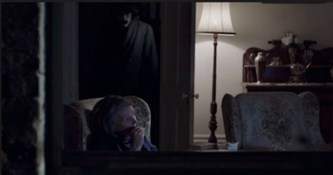  The Wendigo hovers over Billy when he is alone and not on his meds. | 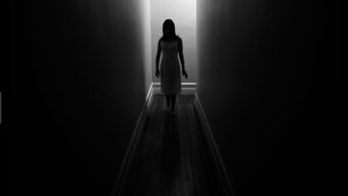  Dream sequence example
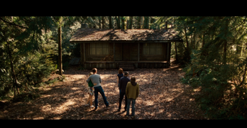  Colour and aesthetic before psychosis. Rez house many years later. | 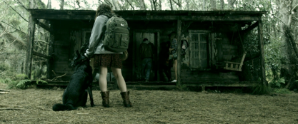  Colour and aesthetic right before psychosis. Rez house many years later. | 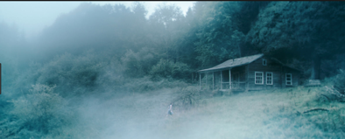Colour and aesthetic during psychosis. Rez house many years later.
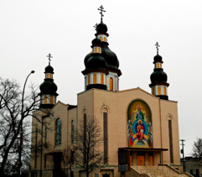  Billy’s church outside | 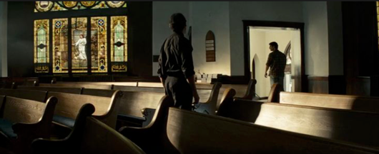  Billy’s church inside where he seeks guidance from Father Barry. | 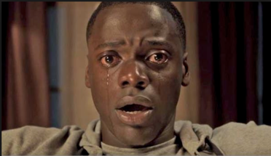  Billy during Psychosis
The overall look and feel is reciprocal of Billy’s mental state. If Billy is in his normal safe environment the overall pacing and aesthetic is warm and welcoming. However, as Billy begins to experience psychosis, the camera begins to move more frenetically and the colours change from warm and welcoming to cool and dark. The biggest inspiration for the visual aesthetic and pace are “The Babadook”, “Cabin in The Woods”, “Don’t Breathe”, and “Get Out” where tension builds and isolation is carried with a cold dark aesthetic as we enter the scary unknown.

