Marketing Plan
Telefilm Talent to Watch
“Billy”

LOGLINE

Billy is a city dwelling, culturally disconnected indigenous man who is being terrorized by a Wendigo spirit. His family means everything to him, so when the Wendigo begins to also terrorize his son, Billy realizes he has to do the one thing he has avoided, return back to his home reservation where it all began.

THE PLAN

Billy draws its strength in the market from 3 key factors:

1.- A unique take on a contemporary Indigenous story

As young First Nation storytellers, we believe the future of thriller and horror is in films with a cultural edge that brings legitimacy to the thriller genre.

Indigenous peoples (of the world) are in themselves a market starved for content with an inward eye.
Billy delivers both the cultural legitimacy and a genuine contemporary Indigenous story. Currently Indigenous peoples are the fastest growing demographic in Canada. Which means at present the fastest growing demographic is starved for content they feel is “for them.” We believe that First Nation, Metis, and Inuit youth coast to coast to coast will genuinely relate to our film, Billy, and develop a certain amount of membership around it.
2.- It is a mental health story.

There is a certain universality that comes with a possession story, from The Exorcist to Amityville Horror, films about possession make us fear our own internal demons.

Cultural phenomenons like “Bell Let’s Talk” have helped create an environment in which mental health issues on the screen are a welcomed addition to a story. We believe this film opens up to that market entirely.

Audiences identify with the internal struggle within the characters and can live the catharsis along with them.

3.- It’s just a great thriller.

Thriller currently holds over 17% of the North American market share in movie attendance and it is a genre that has a faithful cult following. Thriller followers have created their own niche festival market and are mostly faithful movie-goers.

With an average age of 23 years old, this movie goers are active in social media and online trends.

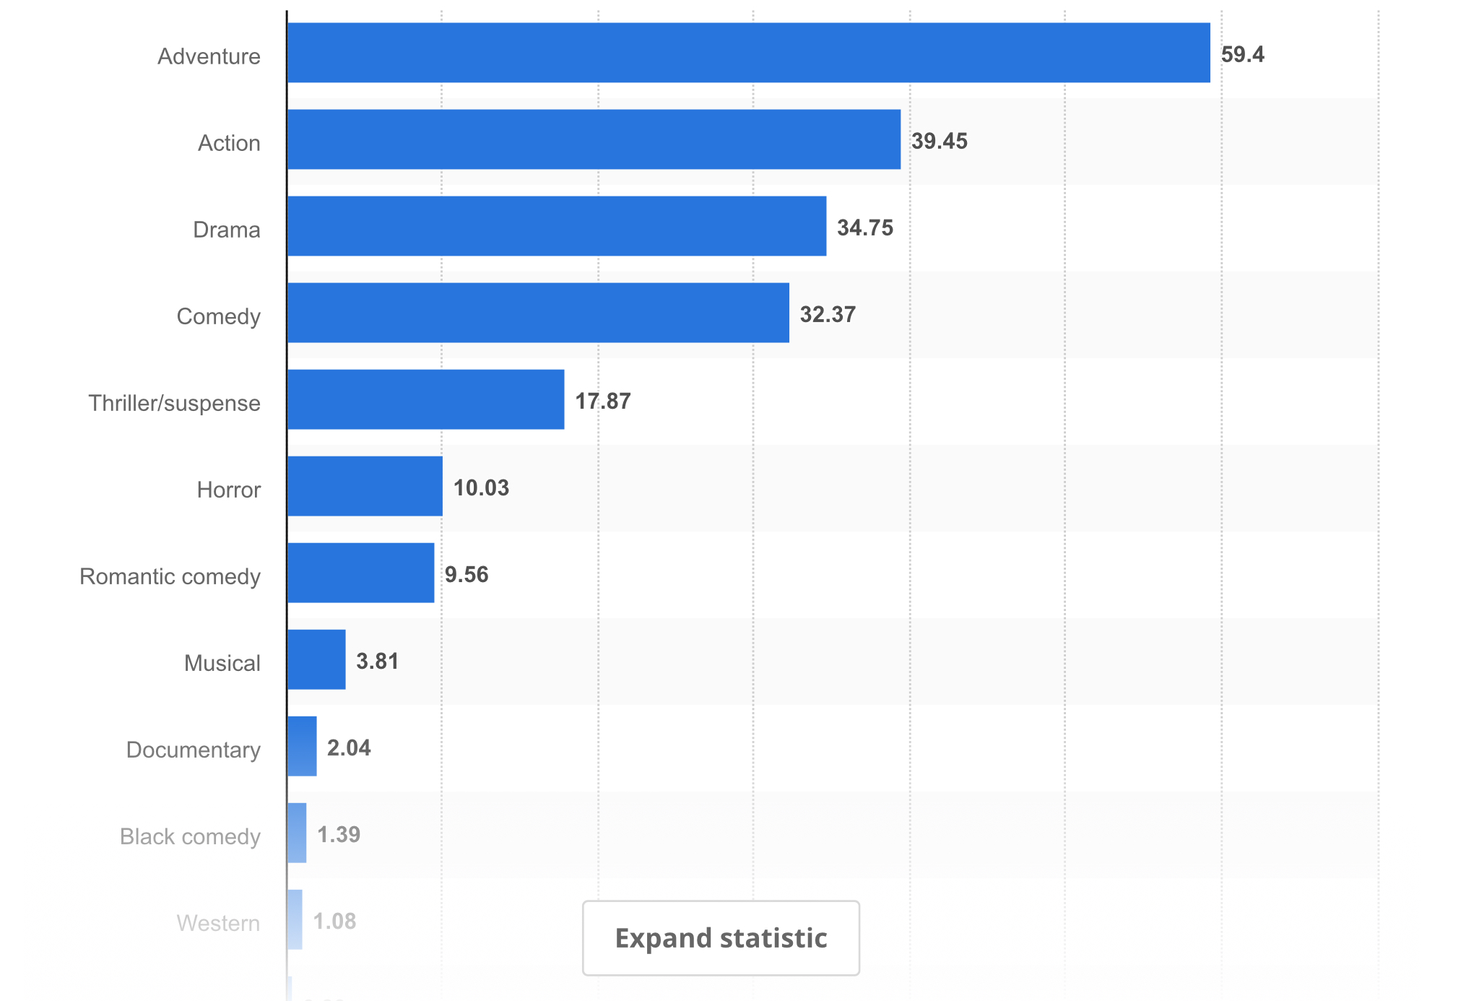

MARKET TARGETS:
- Young men and women ages 15-35
- Women ages 35-50
- Indigenous groups both male and female 15-50

The largest percentage of people who view thriller movies areage 50+(26%). 18-24 year olds are the next largest percentage of viewers at 23% and are 12% of the general population,therefore they are the largest viewers with a high tendency to female engagement.

MARKET GROWTH

Both 2016 and 2017 were great years for the thriller market. With films like “Get Out” acquiring organic notoriety regardless of its budget. In 2018/19 its expected we’ll see growth in attendance at theatres and engagement from audiences.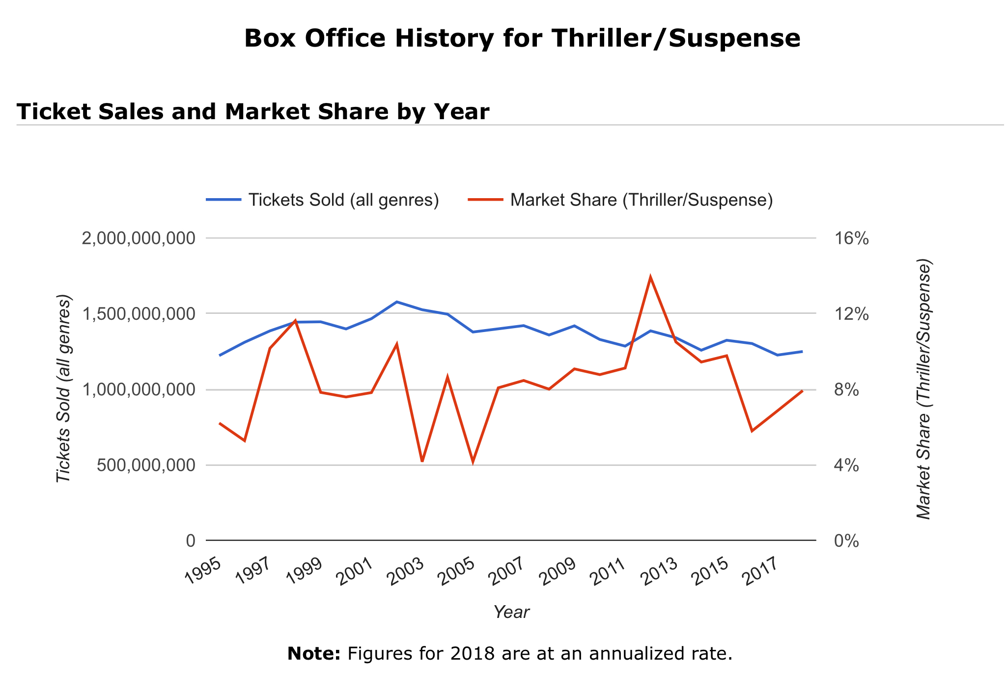

DISTRIBUTION AND PROMOTION

EVENT SCREENINGS
Event Screenings will be a key part of the film's distribution.

Director Jordan Molaro has a well cemented reputation in reservations across Canada and we believe individual engagements in reservations will drive attendance and vitality to the project.

We will engage all 63 First Nations in Manitoba as a start and grow the film organically in that market and eventually expanding to the rest of the First Nation reservations across Canada.

This is a perfect example of how a niche market can create a marketing explosion with a very simple approach.

At the same time we will approach the following festivals as a way to engage distributors and audiences.

Target Film Festivals:
Internally Acclaimed Film Festivals

- Toronto International Film Festival - September
- Sundance Film Festival - Jan
- Tribeca Film Festival - April
- Canne Film Festival - May

Indigenous Film Festivals
- Dreamspeakers Film Festival - August
- Imaginative - October
- American Indian Film Festival - November
- LA Skins Fest - November
- Winnipeg Aboriginal Film Festival - December

Horror and Fantasy Film Festivals

- Brussels International Fantastic Film Festival – BIFFF - April
- Fantasporto, Portugal - February
- Frightfest, UK - August
- Bucheon International Fantastic Film Festival, Korea - July
- Screamfest, US - October
- Sitges Int. Fantastic Film Festival of Catalonia, Spain - October
- Toronto After Dark Film Festival, Canada - October
- A Night of Horror International Film Festival, Australia - October
- Imagine – Amsterdam Fantastic Film Festival, Netherlands - April
- Atlanta Film Festival, US - April
- Fantastic Fest, US - September
- Fantaspoa Film Festival, Brazil - May
- Fantastisk Film Festival, Sweden - September
- Festival Buenos Aires Rojo Sangre, Argentina - November
- Neuchatel International Fantastic Film Festival, Switzerland - July
- Ravenna Nightmare Film Festival, Italy - October
- Telluride Horror Show, US - October
- Abertoir Horror Festival, UK - November
- Atlanta Horror Film Festival, US - October
- Bilbao Fantasy Film Festival, Spain - May
- Buried Alive Horror Film Festival, US - November
- Dead by Dawn UK, April
- Dragon Con Independent Film Festival, US - September
- Eerie Horror Film Festival, US October
- Freak Show Horror Film Festival, US - October
- Horrible Imaginings Film Festival, US - September
- Killer Film Fest, US - November
- Leeds International Film Festival, UK - November
- Motelx- Lisbon International Horror Film Festival, Portugal - September
- New York City Horror Film Festival, US - October
- Raindance Film Festival, UK - September
- Sacramento Horror Film Festival, US September
- Shriekfest, US - October
- Yubari International Fantastic Film Festival, Japan - February

PARTNERSHIPS

We have received interest from Phyllis lang, president of “Buffalo Gal” pictures and “Insidious films”. This partnership will help us develop relationships to generate international distribution and help cement a theatrical release.

In addition to Phyllis, Vice Media has shown interest in distribute Indigenous content from Nu Media Films including a feature film after our recent collaboration of with head of content, Patrick McGuire.

ADDITIONAL HELP WITH DIGITAL MARKETING STRATEGY
We have teamed up with Annelise Larssen [see bio in TEAM section above] for various marketing consultations. She is assisting the creative team to bring this campaign to fruition. Annelise we will use these three factors to develop a campaign that starts with indigenous youth and develops as an international growing movement.

The “niche to worldwide” effort will see a strong social media campaign that will draw from the film’s own cast and key creative’s precenses online. (Roseanne Supernault, The Mariachi Ghost, Nu Media, Kyle Nobess) and then draw from Indigenous influencers like Mike Scott, Ashley Callingbull, ETC. to help a movement will extend to non Indigenous Canadians very soon after the film becomes a well cemented online presence.

Part 1: Digital Market Research & Strategy (1-2 months)
- A brief overview of up to three key demographic group profiles with examples of key potential superfans/online communities & conversations
- Review of existing website and social network presence and gather available data for benchmarking
- A review of key strategic issues in the digital competitive landscape of the Strengths, Weaknesses, Opportunities and Threats for this film (a SWOT analysis)
- Basic keyword research and confirmation of 100 search terms relevant to this project, along with a short-list of recommended terms for optimization & content strategy
- Consultation on the digital media (DM) creative and technological component for this application;
A 12 month timeline and strategy for rollout of a digital marketing plan to support online distribution and audience development. Recommended tactics would employ best practices and could include (but are not limited to):Search engine optimization (SEO) of your website, social media and app store presence, Paid search advertising, Content marketing, Blogging, Microblogging, Social media marketing using tools like Facebook, Twitter, Google+, Digg, Delicious, and YouTube, Advertising on niche community sites and/or targeted social media, Video search optimization and social video optimization, Strategic link building, And online PR and reputation management.
Part 2: Applied Digital & Social Media Marketing (Months 3-12)
- Applied Website & Google+ Optimization for Discoverability (Months 3-4)
- Review of Google Analytics setup (and assistance setting up, if necessary)
- Review of Google and Bing Webmaster Tools setup (and assistance setting up, if necessary)
- Summary of basic recommendations to optimize site-wide and social media for search friendliness.
- Review key content/website text related to client’s most important keywords; provide specific recommendations for improvements on up to 5 key pages; generate and/or edit text of up to 200 words per page
- Provide high level recommendations for up to 10 topics that should be included in the website and social media content strategy
- Provide consultation to improve context and focus of internal cross linking and custom 404 error page;
Provide consultation to ensure effective integration of social media into website.
- Provide consultation on relevant rich snippet markup
- Consultation on setup and submission of XML Sitemap to Google and Bing.
- Setup or optimize page for client on Google+ (the most important social network for strong performance on the Google search engine)
- Apply recommendations for optimization of existing social media profiles.
- Regular Social Media Participation, Digital Reporting, Tracking and Review (Months 3-12):*
- Creation & uploading of posts/tweets/social media ads
- Monitoring and management of all social media interaction
- Ongoing engagement with key social media influencers identified in digital strategy document
- Summary of website activity: # of visitors, available demographics, search engine & social media referrals, top content pages, conversion to action, etc. Client to supply access to metrics tool
- Summary of social media activity, impact & reach: # of visits, available demographics, summary of most engaging activity and content, etc.

EPK STRATEGY

In order to facilitate engagement online. We will create an EPK video campaign that let’s our audience see the reality of making a movie on a First Nation Reservation. Behind the scenes footage of our film and it plight will form a vital part of our online strategy.

Why Billy?

Our creative team is incredibly passionate about this story and we believe that we have a great film that will entertain, inform, and thrill audiences worldwide. Billy represents an effort that will change how we make films by, with, and for Indigenous people and Canadian audiences alike.

