Billy - What Sets us apart
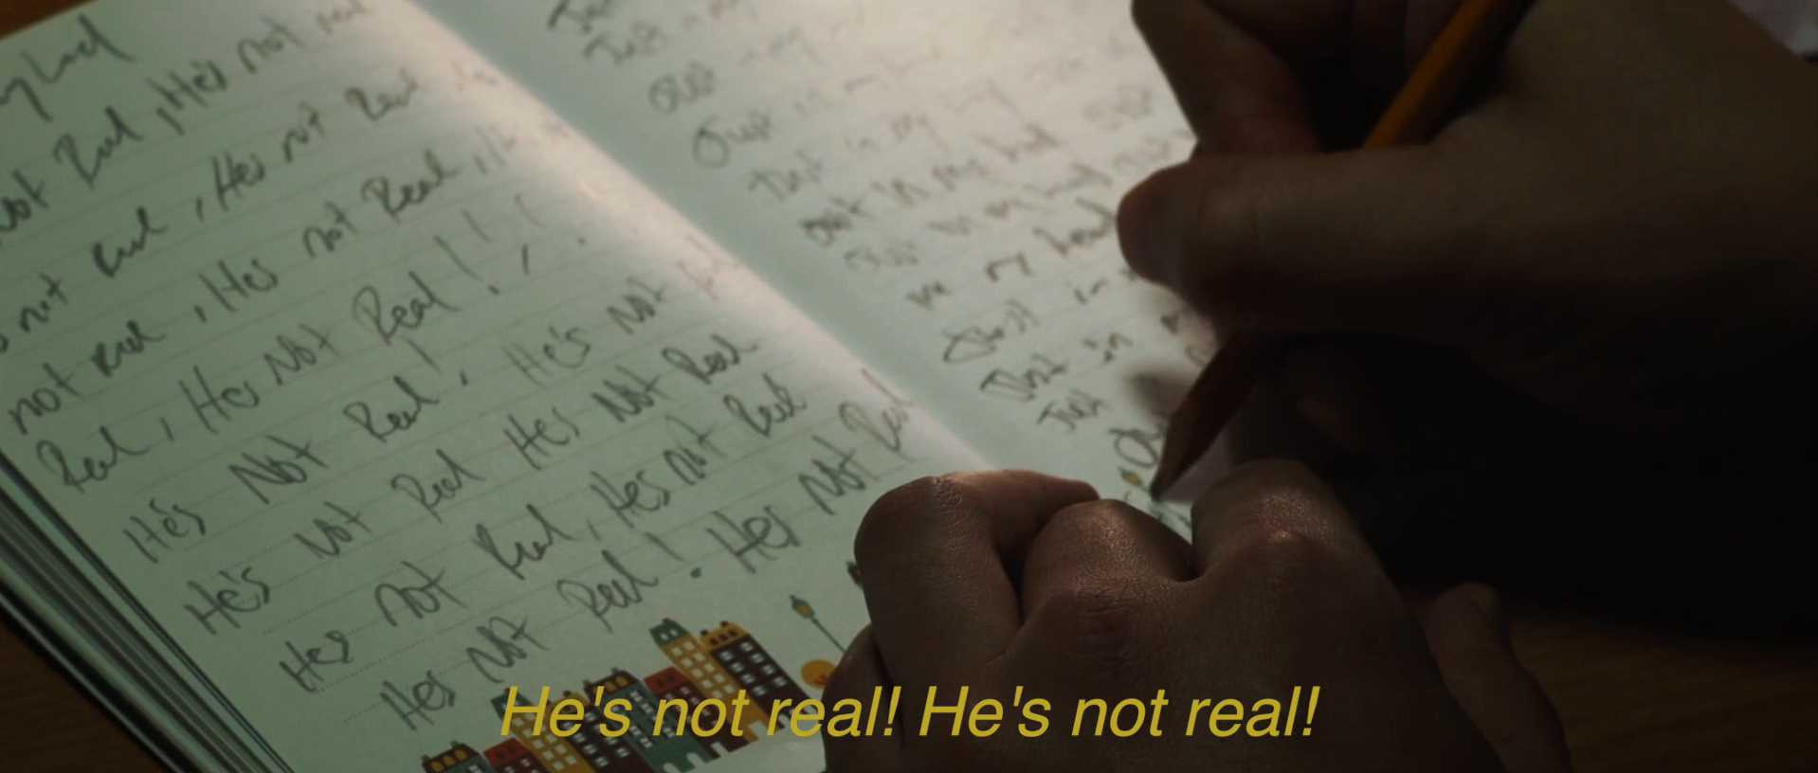

Billy is a city dwelling, culturally disconnected indigenous man who is being terrorized by a Wendigo spirit. His family means everything to him, so when the Wendigo begins to also terrorize his son, Billy realizes he has to do the one thing he has avoided, return back to his home reservation where it all began.

We have an incredible Indigenous cast who all have a strong social media following and are in tune with the demands of the film industry. We look forward in the potential of working with Indigenous communities in Manitoba and across Canada to create something they love as much as we do. As a company, Nu-Media Films has developed an intricate relationship with many First Nations through training programs, community, broadcast, and corporate work. Within Canada we have become an established name within Indigenous households and believe this presence will become the springboard for our first feature film, Billy.

We have had tremendous support from the Manitoba Film Industry over the past 15 years each as writers, actors, and producers.

The Head of Content of Vice Media, Patrick McGuire and new Head of Content Tania Natscheff has shown interest to distribute Billy as well with our contacts at Secret Window (Entertainment One) to help us in any way they can with the digital media component.

Phyllis Laing of Buffalo Gal Pictures is also coming on board Billy in an advisory capacity and to and is interested in further helping in development through her strong network in the horror genre.

Billy is born out of a need to create something that doesn’t yet exist. A film that tells an Indigenous traditional story from an Indigenous perspective. We are in essence taking back control over our stories. Something we feel is lacking in the Canadian media identity. Controlling the message and reclaiming our power though this medium. In our view this is a step toward artistic self-determination and we love that. We believe audiences will love it too.

